# Assignment 2 – Vehicle dynamics

Matteo Gravagnone s319634, Danilo Guglielmi s318083

### Introduction

In this report, we are going to analyse the implementation and simulation of a rear-wheel-drive electric passenger car in MATLAB and Simulink. The target of the work is to develop a model of a vehicle motion and carry out simulations of different cases, related to the main elements involved in the longitudinal dynamics (acceleration, friction braking, energy consumption, regenerative braking)

As a case study vehicle was given in the assignment, a set of parameters was already provided in Table 1 and, whenever required, reasonable assumptions were made in order to obtain a complete and consistent description of the vehicle.

Table 1 - Main vehicle parameters

|  |  |
| --- | --- |
| E. machine peak power | 150 kW |
| E. machine maximum torque | 310 Nm |
| E. machine maximum speed | 16000 rpm |
| Gear ratio | 10.5 |
| Usable battery capacity | 58 kWh |
| F-to-R friction brake torque distribution | 75:25 |
| Kerb weight | 1812 kg |
| Wheelbase | 2.77 m |
| F-to-R mass distribution | 50:50 |
| Frontal area | 2.36 |
| Aerodynamic drag coefficient | 0.27 |

### Description of the model

The overall model consists of multiple subsystems, each one of them modelling different aspects of the vehicle.

#### Wheels

4 independent wheels, which share a common referenced model, take as inputs the vertical load, friction coefficient, velocity of the vehicle and applied motor and braking (due to dissipative brakes) torques.

According to the Pacejka 96 tyre model, forces are computed and, in our case study, only the longitudinal component is used in next steps.

A second subsystem, regarding wheel dynamics, applies the moment balance equation, which considers torque given from the motor, friction brakes, rolling resistance and longitudinal force, to compute the angular acceleration and speed.

Tyre longitudinal slip is computed as a function of the vehicle speed and the obtained angular speed, it can be fed either directly to the Pacejka function or to a subsystem which models tyre relaxation and computes a delayed slip ratio based on a mass-damper first order dynamics similarity, based on values set in the script.

#### Longitudinal dynamics

Acceleration and speed at the CoG are computed based on the force balance equation, which considers the total longitudinal force, aerodynamic drag, gravity (due to possible inclination, but always set to 0 in our examination) and rolling forces.

As some of the formulas hold only for non-negative speeds, a saturation block is used.

#### Power losses

The model considers different power losses which influence the achievable performance in different use cases. The main losses are given from rolling resistance, aerodynamic drag, powertrain, transmission and longitudinal slip.

Their contribution can be evaluated both in terms of their profile over time and total energy consumption over a given test.

#### Vertical load distribution

The computation of vertical force *Fz* for each wheel takes into account also load transfers due to aerodynamic drag and non-zero acceleration while it neglects the aerodynamic downforce and the rolling resistance parameter *Δx* which shifts the application point of *Fzr* and *Fzf*, as it was considered negligible in prior simulations.

#### Electric machine

The motor speed is computed as a function of the vehicle speed, gear ratio and wheel radius. Then, a MATLAB function computes the maximum available torque that can be produced at a given motor speed. This default behaviour can be modified by test cases in which we’re interested in specific torque profiles, while preserving the torque/speed characteristic of the electric motor.

A PI controller was implemented to reach and maintain a reference speed, and a P controller was used to ensure maximum regenerative torque while complying with regulations about front to rear distribution.

Furthermore, a transfer function was added in order to model a realistic motor with a given torque generation time constant.

#### Battery

The available energy from the battery is computed starting from an initial State of Charge (SoC) and the nominal capacity. It is then modified during the simulations based on the energy requested or given from the Electric Motor, after taking into account the efficiency of motor and inverter. It has to be noticed that the implemented mechanism can also manage recovered energy obtained during regenerative braking in a consistent way. The SoC is updated at each time step.

#### Braking System

Our friction braking system consists of 4 individually controlled brakes with a fixed front-to-rear brake torque distribution.

To compute the total braking force, we first compute the force by multiplying the maximum force produced by the brakes and a pedal position. Then, it is saturated by the maximum force available for the given vertical force of the front *Fzf* and friction coefficient *μ*. The rear braking force is then derived from the front one and the fixed distribution. A last saturation step is introduced to limit the braking force on the rear. The threshold defined for this step was chosen under the actually available force, as this emulates the behaviour of systems such as EBD.

The output of the subsystem is a non-negative braking torque *Tb* applied to the corresponding wheel model.

A first-order transfer function, also in this case, was added in order to simulate a realistic behaviour of the braking system.

### Tests

The previously mentioned model was used to carry out simulations of the vehicle in a variety of use cases which belong primarily into acceleration tests, range tests or braking tests, both with regenerative and dissipative brakes.

#### Longitudinal acceleration test

In this test, executed in high tyre-road friction conditions, we analysed the vehicle behaviour under acceleration. Different initial and final speeds were chosen to cover a variety of relevant cases.

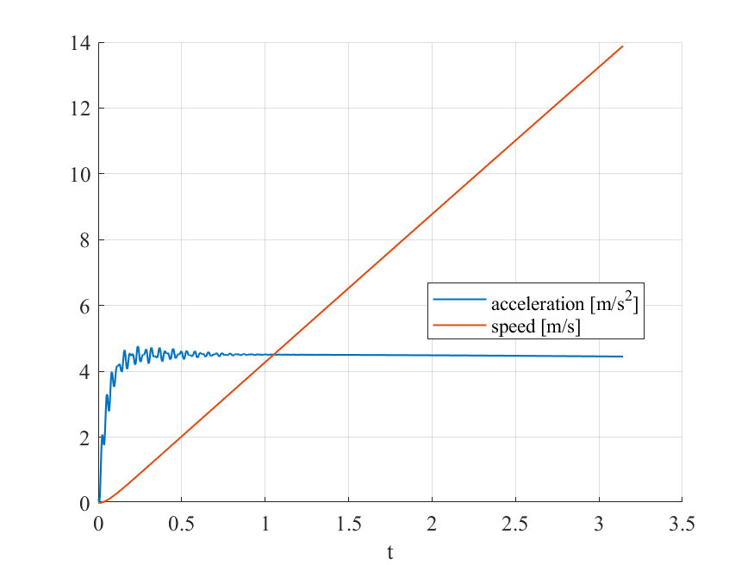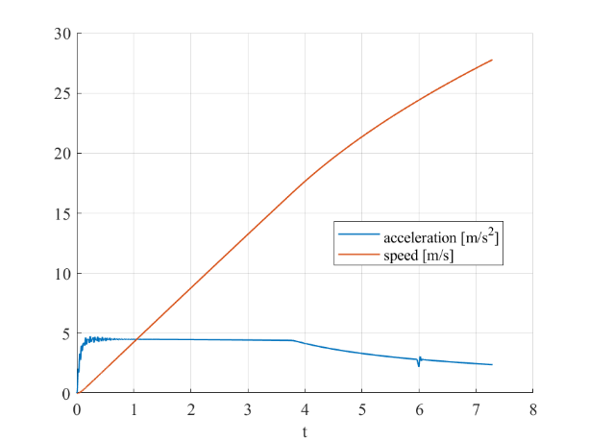

Figure 1‑a 0-50 Km/h and Figure 1-b 0-100 Km/h

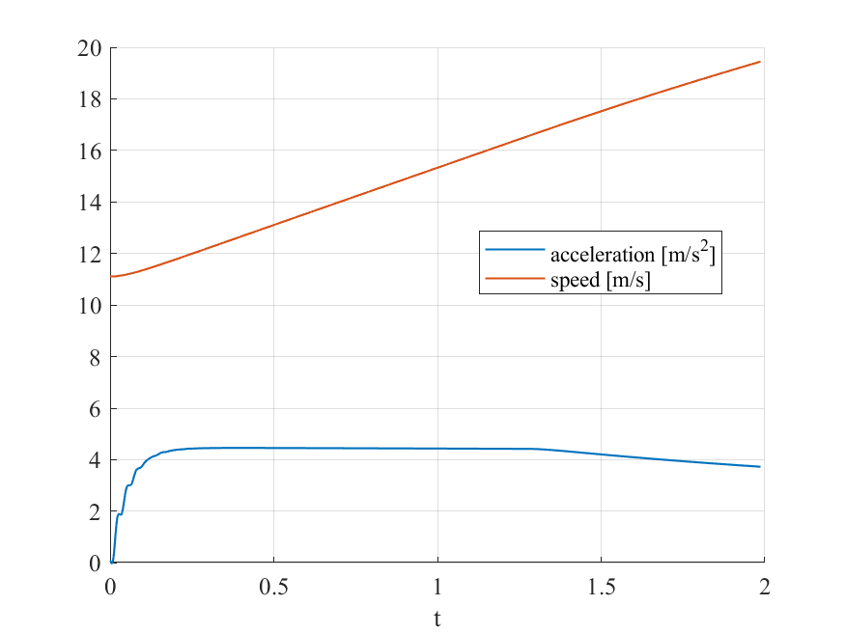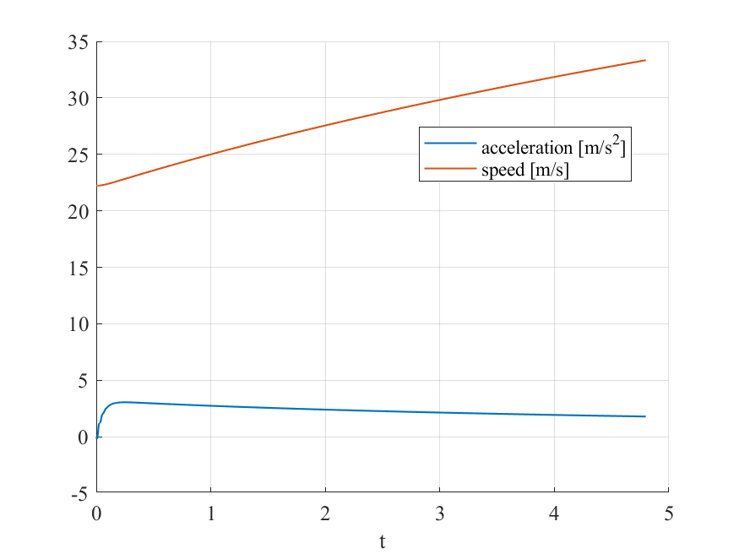

Figure 1‑c 40-70 Km/h and Figure 1-d 80-120 Km/h

The results of the simulations, in this set of relevant acceleration tests, show realistic behaviour of the vehicle, with characteristics such as the responsiveness typical of a rear-wheel drive electric passenger car. The acceleration has a nearly constant profile; however, it is possible to see oscillations, especially when starting from zero speed, due to the modelling of tyre relaxation. The speed, as expected, shows a linear behaviour which is visible in the Figure 1‑a or 1-c, and becomes more complex as the speed increases, along with aerodynamic drag, which can be seen in Figure 1‑ab or 1-d.

Another simulation was performed to find the theoretical top speed of the vehicle, which hovers around 214 Km/h.

Table 2 - Relevant acceleration times

|  |  |
| --- | --- |
| Considered tests | Time |
| 0-50 Km/h | 3.14 s |
| 0-100 Km/h | 7.29 s |
| 40-70 Km/h | 1.99 s |
| 80-120 Km/h | 4.80 s |

One of the aspects we considered is the energy loss accumulated during our tests. For each test, we calculated some of the main power losses associated with aerodynamic drag, longitudinal tyre slip, powertrain, rolling resistance, and transmission. In Table 3 we report the energy consumption over the duration of each test for each loss.

As we expected, in tests in which the vehicle reaches high speed, the contribution of the aerodynamic drag increases, like in “0-214” test case where it has the highest value.

Table 3 - Energy consumption in “Longitudinal Acceleration Test”

|  |  |  |  |  |  |
| --- | --- | --- | --- | --- | --- |
| E loss  [Wh]  Test [km/h] | Aero Drag | Long Slip | Powert rain | Rollin Res | Transmis sion |
| 0-50 | 0.22 | 2.88 | 6.02 | 1.06 | 2.71 |
| 0-100 | 5.15 | 9.75 | 25.10 | 6.24 | 11.30 |
| 40-70 | 0.81 | 3.61 | 8.07 | 1.64 | 3.63 |
| 80-120 | 11.95 | 4.95 | 22.08 | 9.77 | 9.93 |
| 0-214 | 1622.48 | 56.51 | 454.50 | 696.26 | 204.52 |

Furthermore, in the same instances, its contribution quickly exceeds the one given from rolling resistance. Additionally, the powertrain power loss is a relevant element to the overall consumption of the vehicle. It depends linearly on the power provided by the electric motor when the requested torque is at its maximum, up to the point in which the peak power is reached. Once it is reached, the powertrain power loss no longer increases linearly but it remains at the same value for every following time step. In addition, the same pattern can be observed for the transmission power loss, although with lower magnitude.

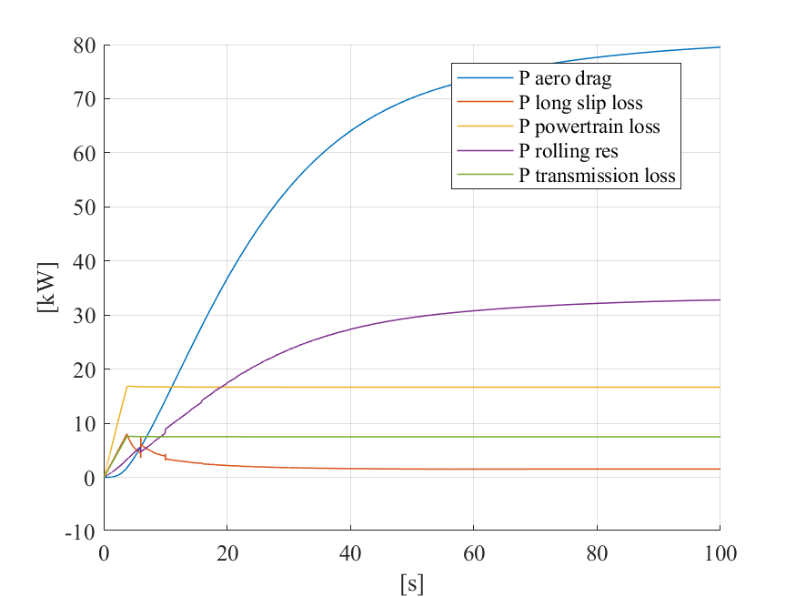

Figure 2 - Power losses over time in the 0-214 Km/h test

#### Energy consumption and achievable range at different constant speeds

In the following test case, we tracked the energy consumption and achievable range during vehicle motion at different constant speed (low, medium and high). The vehicle starts with a full battery and the simulations are carried out until it is completely depleted.

|  |  |  |  |  |  |
| --- | --- | --- | --- | --- | --- |
| E loss  [kWh]  Test  [km/h] | Aero Drag | Long Slip | Powertrain | Rollin Res | Transmission |
| 30 | 3.63 | 0.06 | 5.80 | 22.97 | 2.61 |
| 60 | 10.70 | 0.09 | 5.80 | 19.40 | 2.61 |
| 80 | 14.94 | 0.11 | 5.80 | 17.24 | 2.61 |
| 120 | 20.76 | 0.19 | 5.80 | 14.25 | 2.61 |

Table 4 – Energy consumption in “Cruise Control Test”

It is possible to observe that the effect of rolling resistance, which requires almost 40% of the capacity at the lowest considered speed, decreases as the aerodynamic drag becomes the highest hindrance at higher speed. However, overcoming the rolling resistance requires a relevant fraction of the available energy at any speed.

Power loss, and thus energy loss, due to longitudinal slip, proves to be, in contrast to what can be seen in the short acceleration tests, a negligible factor in the range of the vehicle, as the slip values become quite low at quasi-null acceleration.

We can also notice that the electric powertrain and transmission losses remain constant in every test. In more detail, as the powertrain efficiency is considered constant in our vehicle, the same value is found when depleting a full battery. Similar reasoning can be done for transmission efficiency, as a given fraction of the motor output power, and thus energy, is wasted and does not reach the wheels.

Table 5 – Achieved range at different speeds

|  |  |
| --- | --- |
| Reference speed | Achieved range |
| 30 Km/h | 492.6 Km |
| 60 Km/h | 364.9 Km |
| 80 Km/h | 288.2 Km |
| 120 Km/h | 181.8 Km |

Overall, we can assert that the vehicle is most efficient when driving at low speed while, in high-speed conditions, the efficiency drastically decreases due to the aerodynamic drag and, to a smaller extent, rolling resistance contribution.

#### Tip-in and tip-off tests

These two tests, normally used to evaluate vehicle drivability, were combined in a singular simulation, in which the torque request is a rectangular window signal.

However, as expected, the simulation results show a response that is very close to an ideal one, as the model does not take into account the effects of the limited torsional stiffness of the half-shafts.

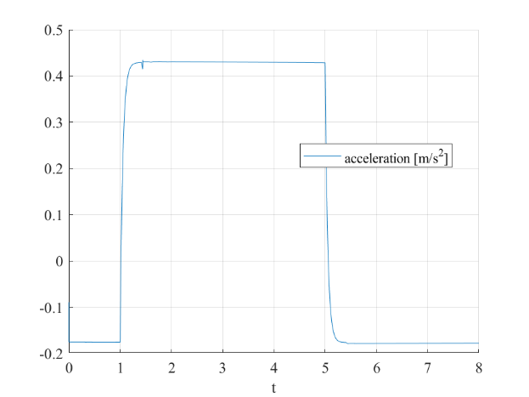

Figure 3 – Longitudinal acceleration in tip-in and tip-out without torsional stiffness

By observing Figure 3, it is evident that there are no oscillations both in the first part of the test, the tip-in, and the second part, regarded as tip-out, as the acceleration is able to match the profile of the torque request.  
  
However, we implemented a specific model (named *model_tipin_tipout*) which considers also the torsional stiffness of the half shafts. This requires a more complex interconnection between the subparts of the model and thus was separated from the default model, which proved to be more robust and was, therefore, chosen to be used in the other tests.

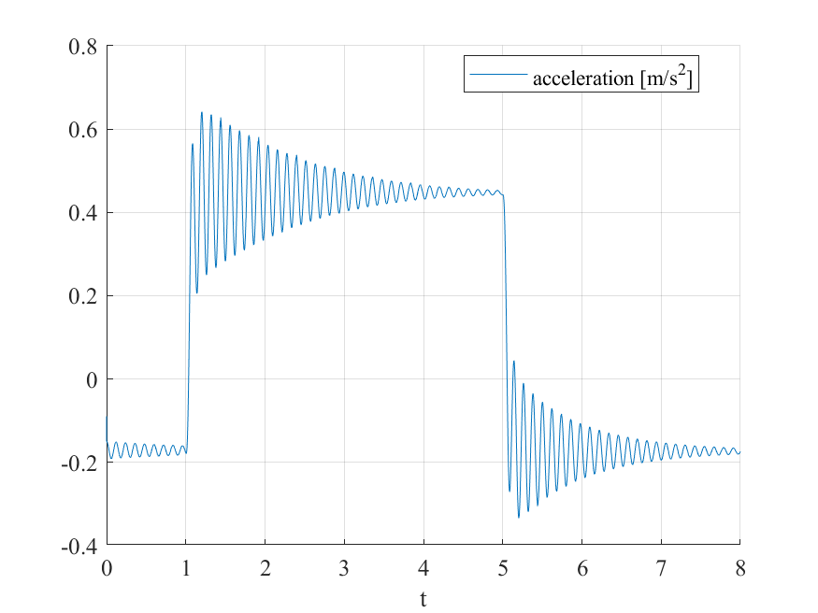

Figure 4 - Longitudinal acceleration in tip-in and tip-out with torsional stiffness

In Figure 4, obtained by simulating the specific model, we can observe the oscillations that characterize this class of tests. Without anti-jerk controls, the acceleration shows the expected behaviour when a sudden jump in torque is requested. The torque profile was accurately chosen in order to obtain a tip-out section that does not show the influence of the initial tip-in section.

#### Regenerative braking with acceleration and braking

A useful characteristic of electric vehicles is the use of the motor to apply negative torque and brake the car while recovering energy.

Three simulations were carried out: in the first test, we start from 30 Km/h and decelerate to come to a stop, and we are able to recover 13 Wh and stop the vehicle in 41 meters; in a second test we accelerate for 5 seconds then decelerate. Of 193 Wh consumed, we recovered almost 107 Wh, wasting only 0.15% of the battery capacity.

In the last test a basic profile of acceleration and deceleration was set in order to observe the response when we are not able to foresee a complete stop. As expected, the percentage of recovered energy is lower, yet significant, at 40.2% of the energy consumed (Figure 5).

The P controller mentioned in the model description applies the formula:

, where is the maximum torque, is the deceleration expressed in g’s and is the maximum deceleration compliant with the European Brake Regulations when the distribution rate is 0 (so= 0.1).

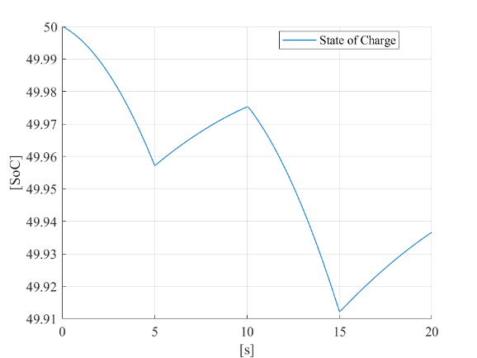

Figure 5 - SoC variation under acceleration and regeneration

#### Emergency braking test

Simulations were conducted both in high-friction and low-friction conditions in order to assess the operation of the dissipative braking system. Although the results differ from those of vehicles with similar properties, the overall behaviour follows the expected one: the stopping distance in good conditions, reported in Table 6 along with those in different conditions, satisfy the EU regulations regarding stopping distance.

Table 6 - Stopping distances in emergency braking

|  |  |  |  |  |
| --- | --- | --- | --- | --- |
|  | **µ = 1 (dry road)** | | **µ = 0.4 (wet road)** | |
| **Velstart**  **[Km/h]** | **50** | **100** | **50** | **100** |
| **Stopping distance [m]** | 15.63 | 57.47 | 35.84 | 134.82 |

The model implements a basic ABS control at an axle level, which saturates the braking force, and thus braking torque, to the maximum value possible at a given *μ*. Furthermore, a similar saturation is applied to the rear brakes in order to simulate a system, such as the EBD, which is able to control the longitudinal movement of the rear axle to avoid potential instability.

The braking system of the vehicle has been modelled as a Category A, where the regenerative braking system is used in throttle-off braking. For this reason, no negative torque is applied from the motor in these tests.

### Conclusion

The model the team built captures multiple elements that characterize the longitudinal behaviour of passenger cars and, in specific aspects, electric cars. It is noteworthy that, despite many simplifications that we highlighted in this report, the process required the comprehension of the items, both in the ideal and real case, and the proper interaction among them.